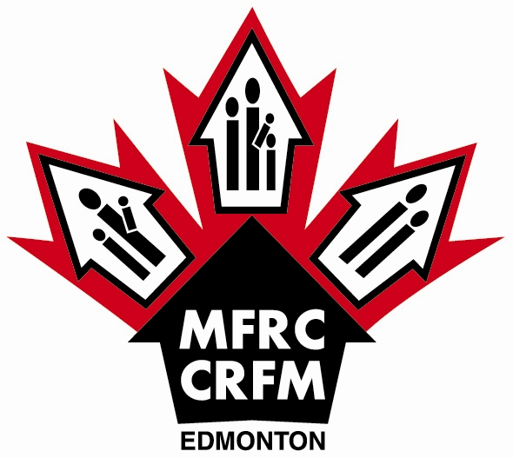

All proceeds go to the Edmonton Garrison Military Family Resource Centre (MFRC) to provide programs, services, and resources for military families.

Yellow Ribbon Lapel Pin - $5
Proudly wear your support with an attractive Yellow Ribbon Lapel Pin.
Yellow Ribbon
Car Magnet - $3.50
Proudly show your support with a bilingual Yellow Ribbon Car Magnet.

Fax to (780) 973-1401; Email to information@mfrcedmonton.com; Phone (780) 973-4011 ext 6300
Mail: Yellow Ribbon Campaign; Edmonton Garrison Military Family Resource Centre
Box 10500 STN Forces; Edmonton AB T5J 4J5 - Canada

Yellow Ribbon Pins / Magnets Order Form (All prices include GST)

Yellow Ribbon Pins Amount Ordered ________ @ $5.00 each = $__________

Yellow Ribbon Magnets Amount Ordered ________ @ $3.50 each = $__________

Shipping: Please add 10% $__________

Total Order: $__________

Name

Mailing Address

City/Town Prov/State

Postal/Zip Code Phone #: ( )

Payment Method: Cheque Money Order Mastercard Visa
(Please make payments payable to the Edmonton Garrison Military Family Resource Centre)

Mastercard # Expiry Date: Month Year

VISA # Expiry Date: Month Year

Signature

How did you hear about the MFRC Yellow Ribbon Campaign?

